﻿# EDA & Data Preparation Summary Report

Project scope: Classification of Inventario status and Lob Associata from product code and description data.

1) Initial Data and Business Glossary (Data Profiling)

Data source
- File: DB for DTM Project.xlsx
- Main sheet: Associazioni Cod. Art. - LOB

Initial dataset profile
- Rows: 22,655
- Core fields: 5

Field | Business meaning | Modeling role | Type / quality
Codice Articolo | Product/article code | Input key feature | object, 22,655 non-null, 22,655 unique
Descrizione Articolo | Free-text product description | Input text feature | object, 22,595 non-null, 60 null (0.265%), 21,283 unique
Lob Associata | Line-of-business code | Primary classification target | int64, 22,655 non-null, 117 unique
Nome LOB | Human-readable LOB name | Input metadata / validation field | object, 22,655 non-null, 115 unique
Inventario | Inventory class label | Secondary target | object, 22,655 non-null, 3 classes

Inventario class distribution (raw)
- Inventario: 19,764
- Non in inventario: 2,880
- Assistenza: 11

2) What Drives Classification (Inventario Rules and Vendor Signal)

Feature signal ranking confirms that structured code and text anchors drive classification quality.

Top signals (dp3_feature_signal.csv):
- code_prefix: 0.680 (weighted purity)
- first_token: 0.674 (weighted purity)
- code_len: 0.359
- duration_months: 0.327
- brand_vendor: 0.220 (weighted purity)

Feature signal chart:

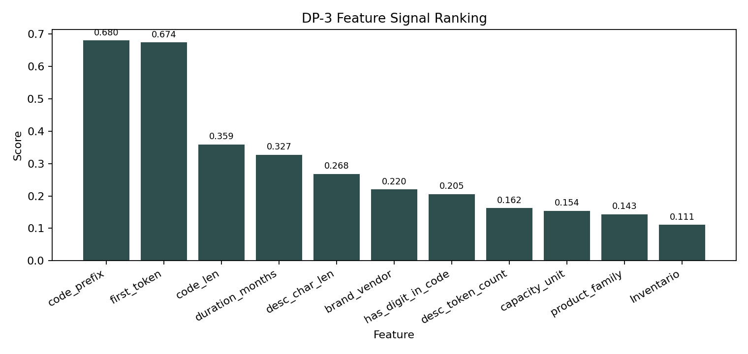
DP-3 Feature Signal

Interpretable code-prefix rules (examples)
Derived from freq_prefix_vs_lob.csv.

Rule | Support | Confidence
prefix=AIR -> LOB 2001 | 243 | 0.938
prefix=UCS -> LOB 3009 | 202 | 0.944
prefix=WS -> LOB 2002 | 195 | 0.970
prefix=UCSC -> LOB 3009 | 136 | 0.986
prefix=NW -> LOB 3005 | 133 | 0.971

Inventory keyword rules (examples)
Derived from freq_keywords_vs_inventario.csv.

Rule | Support | Confidence
keyword="-c" -> Inventario | 291 | 0.986
keyword="normal" -> Inventario | 154 | 0.939
keyword="factory integrated" -> Inventario | 106 | 0.930
keyword="sw" -> Inventario | 103 | 0.954
keyword="renew" -> Inventario | 80 | 0.930

Vendor effect
Vendor extraction is informative and not marginal:
- brand_vendor scored 0.220 in feature signal ranking.
- In EDA diagnostics, first_token_brand_precision_proxy = 0.951695 on overlapping known-brand rows.
- Rows with recognized vendor label (brand_vendor != unknown): 6,710.

3) Data Problems and How They Were Resolved

Main quality issues detected (DU-4)
- description_with_multiple_targets: 271 (conflicting descriptions)
- blank_description: 61
- duplicate_rows_all_cols: 0
- code_with_multiple_targets: 0

Additional semantic issue (LOB naming consistency)
From simple_checks/summary.txt:
- Nome LOB -> many LOB: 2 problematic names
- BUILDING AUTOMATION
- VIDEOSORVEGLIANZA

Resolution strategy (DP-2)
- Safe target relabeling using grouping_lob_autofix_safe.csv
- Raw rows relabeled: 54 (fix_by_name_prefix2)
- Relabeled rows retained in final cleaned set: 49

- Stage A pre-pruning (source-driven)
- Source LOB excludes (78*, 01003, 01009, 01015, 01011): 1,161
- Service rows marked as Inventario: 222
- LOB not in LOB catalog: 0
- Union pre-pruned: 1,383

- Stage B pruning (quality/label integrity)
- Assistenza pruned: 11
- Non usare patterns pruned: 31
- Blank description pruned: 62
- Description-to-multi-target conflict rows pruned: 701
- Union pruned (Stage B): 773

- Duplicates after pruning
- Removed: 0 (none found)

4) Associative Rules from Description Word Matrices

Association matrices were built as normalized conditional distributions P(class | token).

Token -> Vendor (dp3_token_brand_matrix_norm.csv)
High-confidence examples:
- catalyst -> cisco (0.996)
- cisco -> cisco (0.983)
- hpe -> hpe (0.965)
- normal -> trend_micro (0.928)
- utp -> fortinet (0.906)

Token -> Product Family (dp3_token_family_matrix_norm.csv)
High-confidence examples:
- subscription -> subscription (0.950)
- poe -> hardware (0.925)
- cable -> hardware (0.867)
- normal -> license_term (0.856)

These matrices are directly usable as interpretable rule candidates and confidence features in hybrid auto/manual routing.

5) Final Analysis and Data Preparation Results

Pipeline outcome
- Raw rows: 22,655
- Final cleaned/model-ready rows: 20,499
- Net reduction: 2,156 rows (9.52%)

- rag_input_dataset.csv: 20,499 rows, 14 columns
- rag_input_dataset_new.csv: 20,499 rows, 14 columns

Evidence from EDA graph
The row flow is confirmed by the stage progression chart generated from dp6_stage_progression.csv:

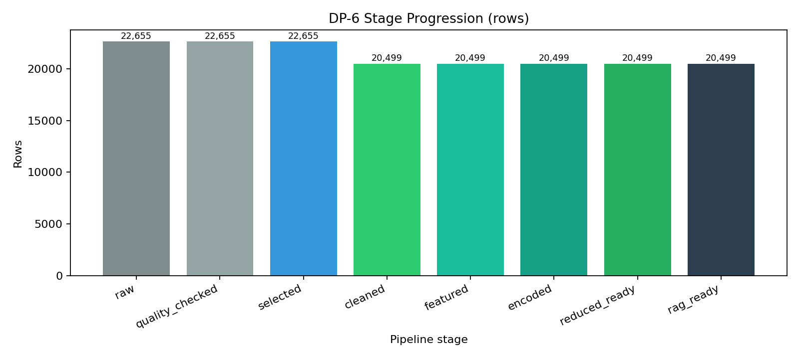
DP-6 Stage Progression

Quantitative modeling readiness gains
From dp5_uplift_summary.csv and dp5_uplift_delta.csv:
- Accuracy: 0.1548 -> 0.2571 (+0.1024)
- Weighted F1: 0.1739 -> 0.3014 (+0.1275)
- Macro F1: 0.1118 -> 0.2109 (+0.0991)

From dp5_pca_summary.csv:
- Cumulative explained variance:
- 1 component: 43.48%
- 2 components: 78.28%
- 3 components: 98.52%

Conclusion
The preparation pipeline removed label noise and ambiguous records, corrected safe LOB inconsistencies, and converted description/code patterns into interpretable signals. The resulting 20,499-row dataset is cleaner, traceable by rule, and measurably stronger for downstream classification and retrieval tasks.

